

HUMBLE SIGN
ORDER TO CASH
PROCESS FLOW DOCUMENT

pg. 1

Order to Cash Process Flow
Login To Role: Sales Manager
Customer Creation

Navigation: Customers -> Relationships -> Customers -> New
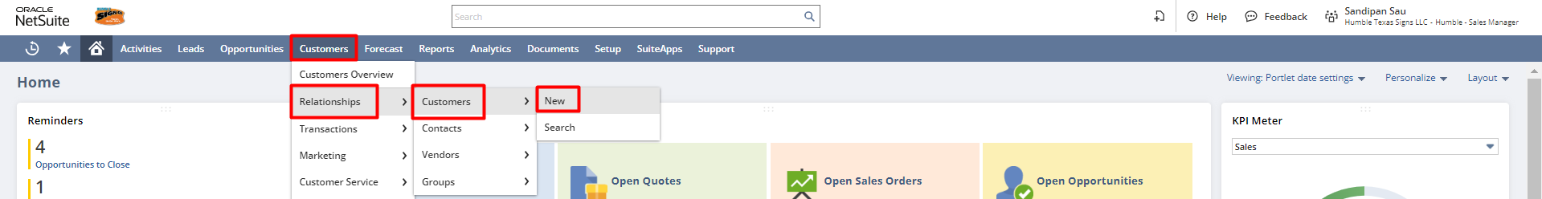

In the Customer record, enter the Company Name, Email, Address, status, and other necessary details.

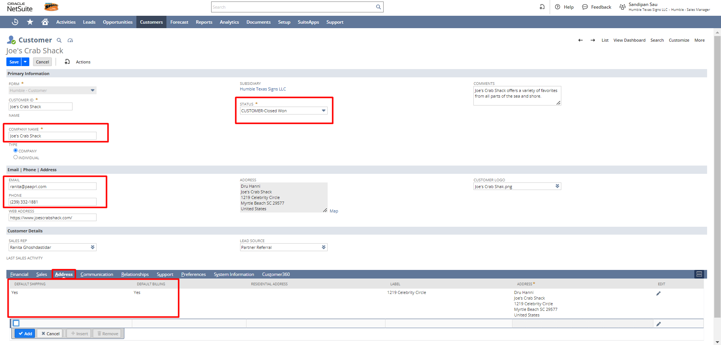

Under the Financial subtab select the Terms, Account etc., and click on Save.
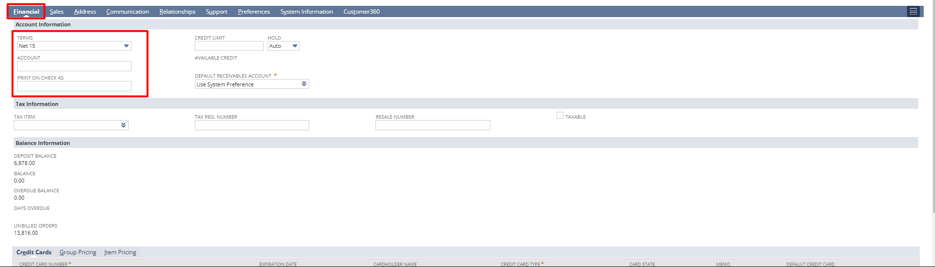
Under the Sales subtab, you can see all those transactions associated with this particular customer.
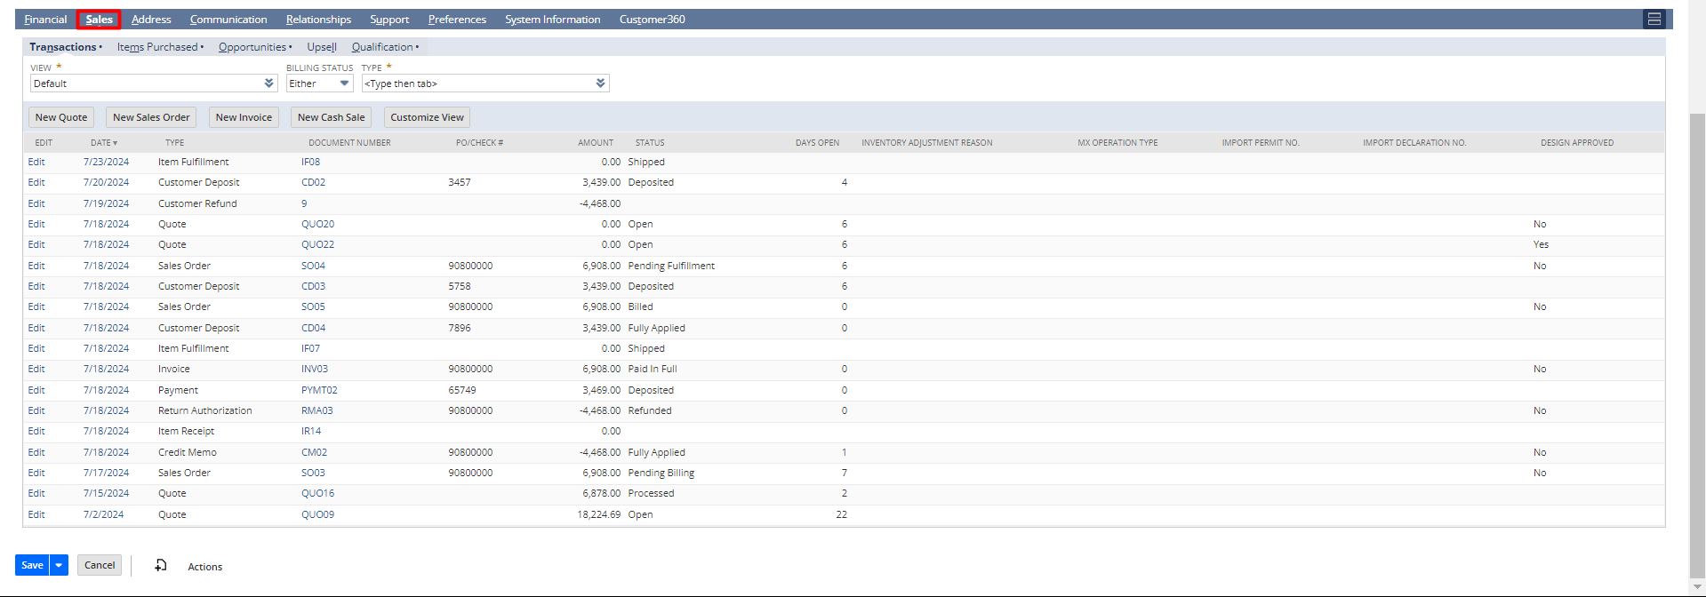
Under the Address subtab, click on the pencil icon to add or edit the address.
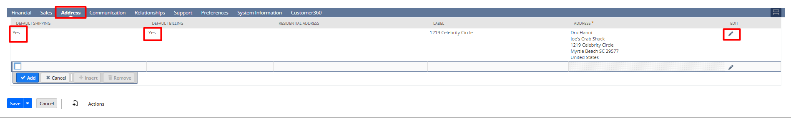

Under the Communication subtab, click on New File to add a new one.
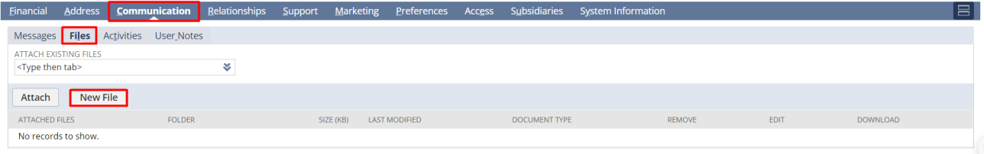

Under the Relationships subtab, click on New Contact to attach a new contact with this customer.
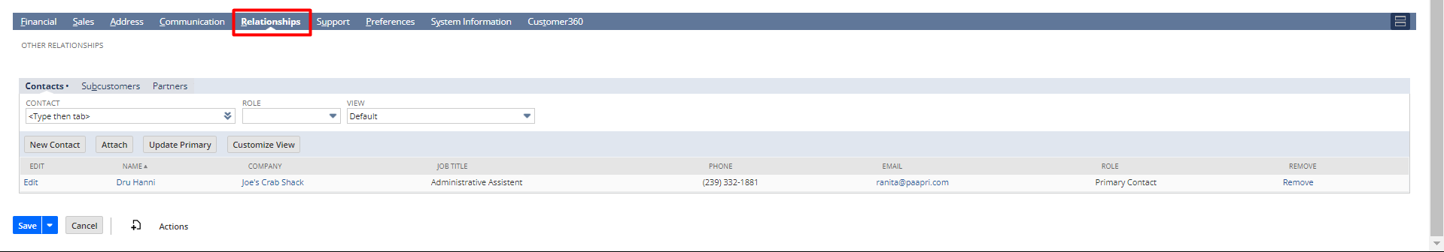

Sales Order Creation from Quote
Navigation: Opportunities -> Transactions -> Quotes -> List.
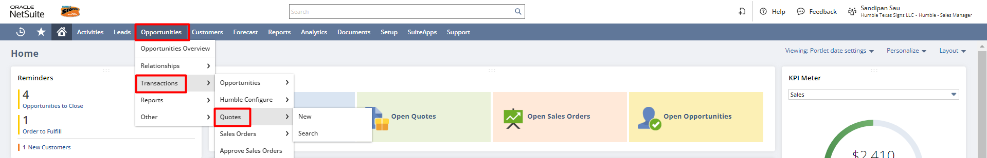

A list of quotes will open and click on the View hyperlink beside the Quote that you want to convert to a sales order.
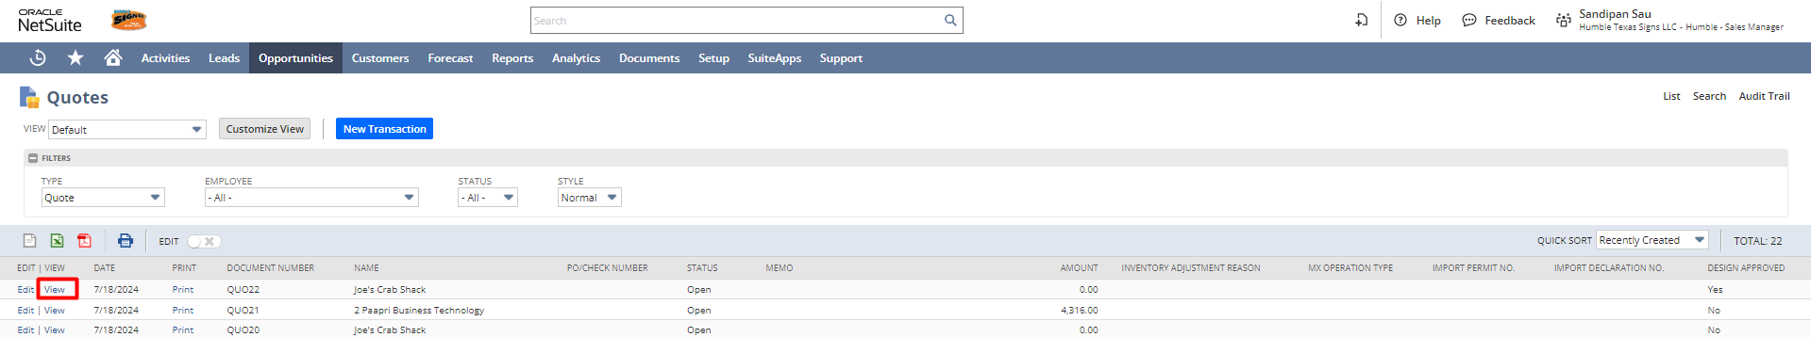
From the view mode of a Quote, click on the Sales Order button and it will open the sales order form with the Quote information.
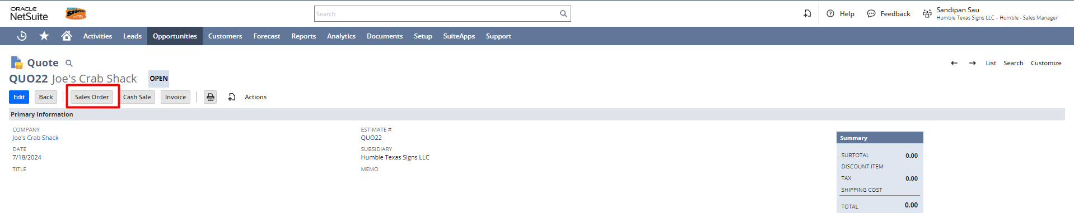
If required, the user can modify the field value and save the record or can directly save the record.
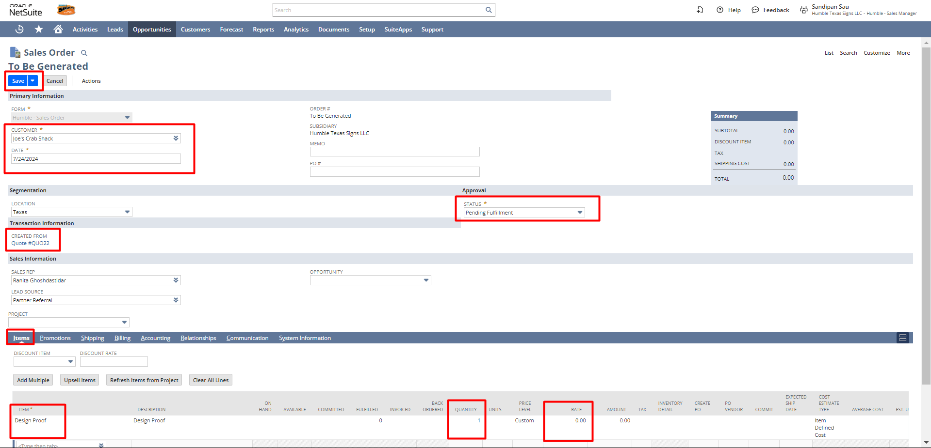
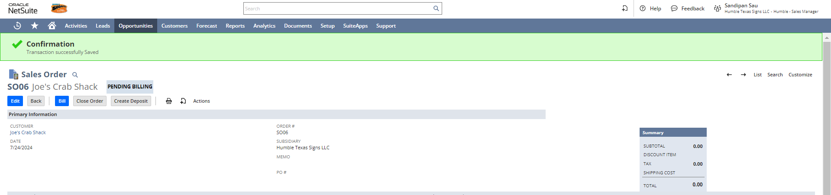
After creating the Sales Order, the user can print the Sales Order transaction PDF and the Picking Ticket from the sales order.
Open the sales order, hover on the print icon, and click on Print to print the sales order & picking ticket.

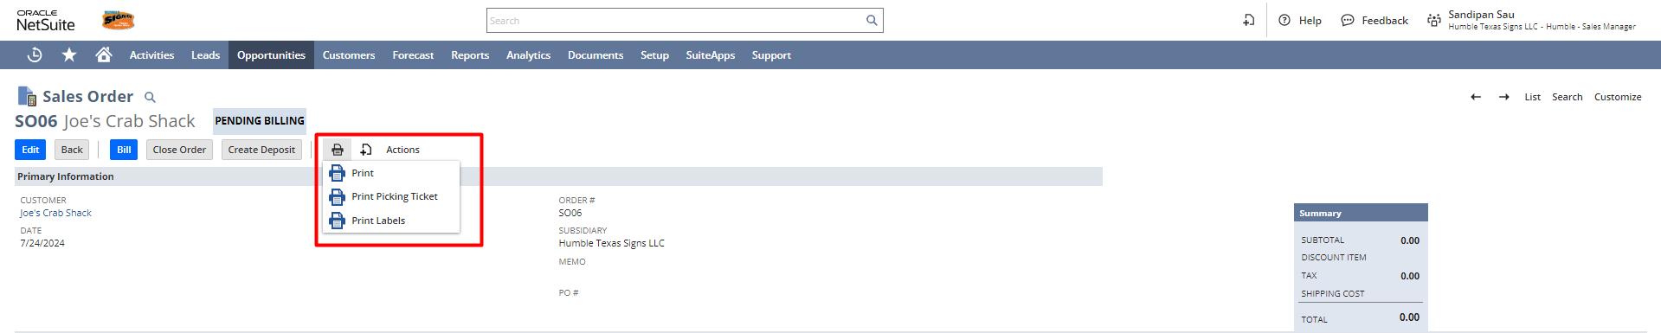

Create Standalone Sales Order
Navigate to Opportunities -> Transactions -> Sales Orders -> New

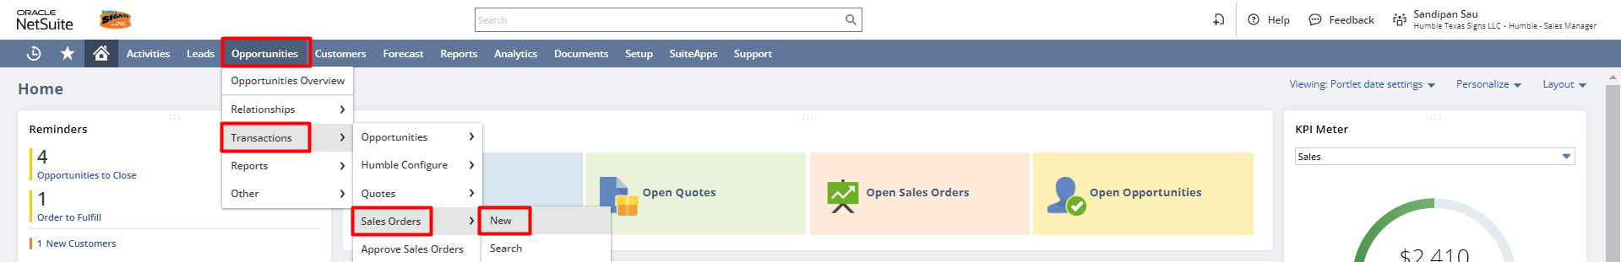

Enter all the necessary details like the customer, memo, PO#, Location, Sales rep, and other necessary information.

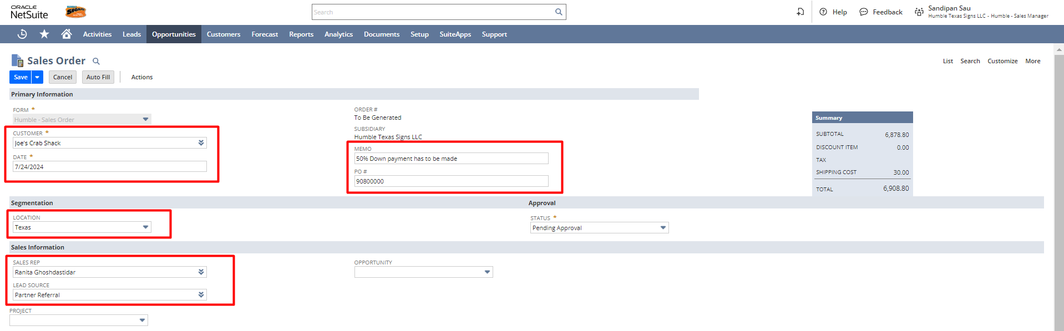
Under the Items subtab select the item, enter the quantity, rate, and other necessary information.

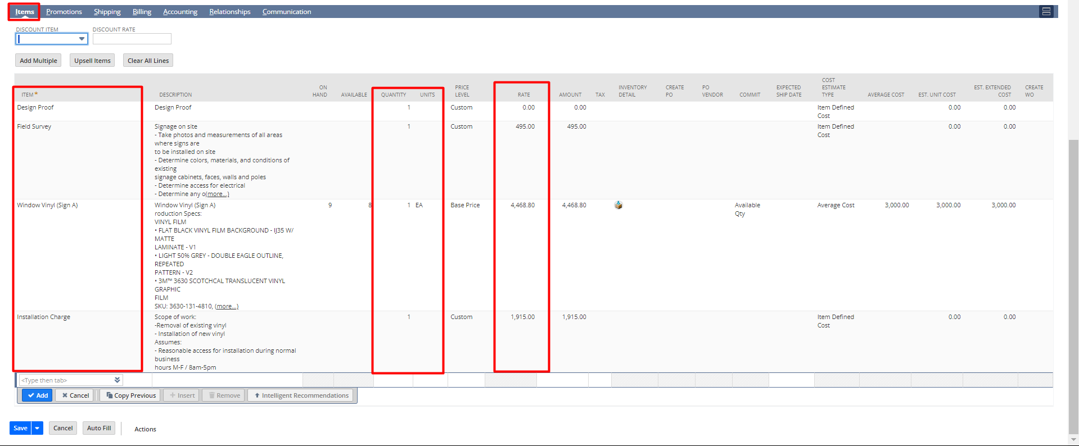

Under the Shipping subtab, the user can select the Shipping Carrier & Shipping method and put the shipping cost. Users can also change the ship to address.

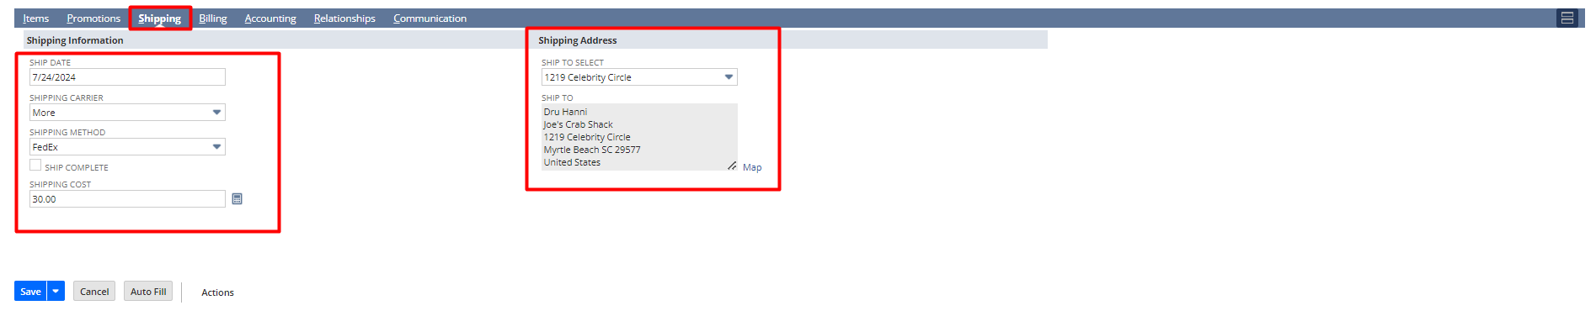
Under the Billing subtab, the User can select the Payment Method, Terms and Bill to address.
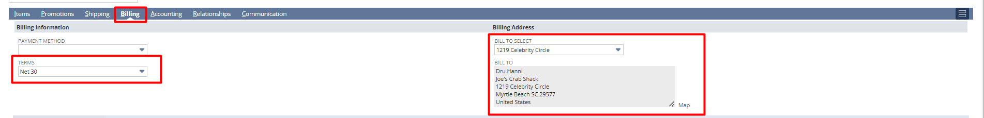

After fill all the necessary details, click on Save button to save the Sales Order.

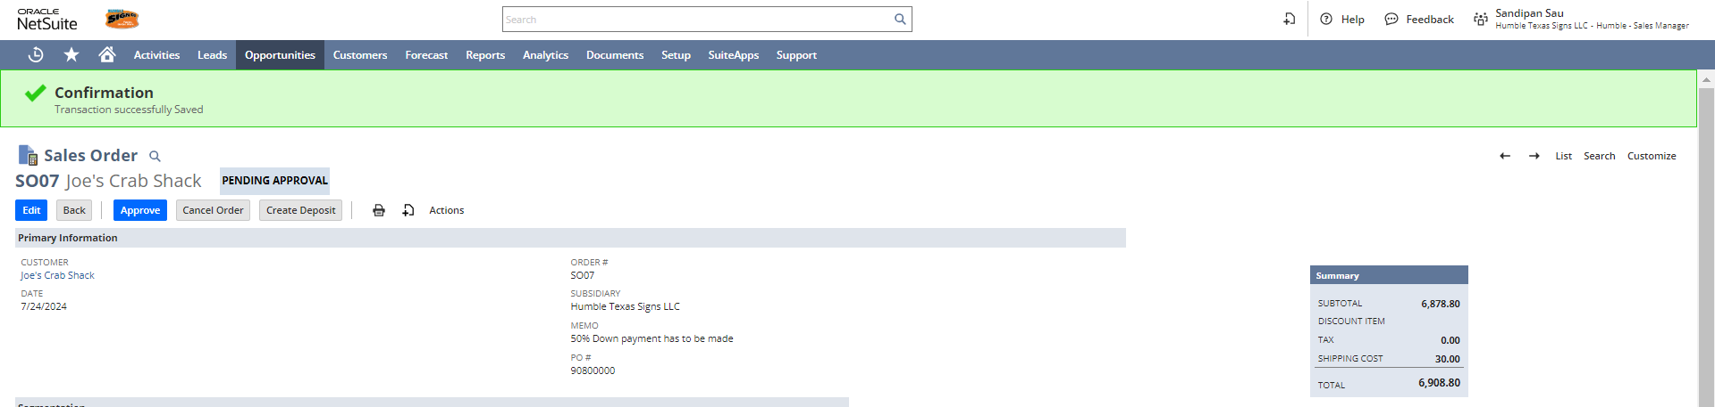

You can print the Sales Order transaction PDF and the Picking Ticket PDF from the sales order.
Open any sales order in the view mode, hover on the print icon, and click on Print to print the sales order, and a new window will open with the sales order PDF. You can download the PDF for later use or you can print the PDF directly from the page.

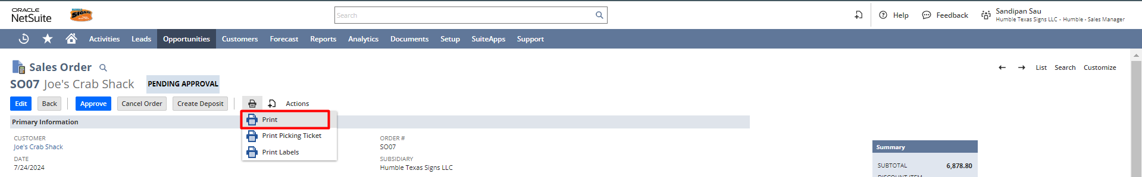
Sales Order Print PDF:
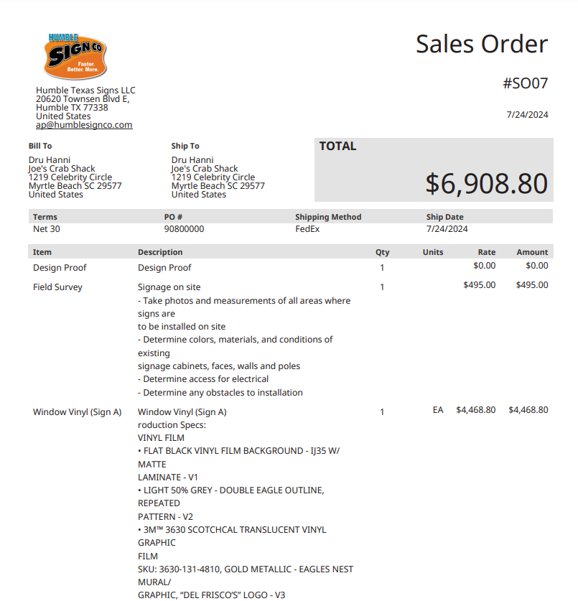

To print the Picking Ticket, you need to follow the previous step and click on the “Print Picking Ticket” option. Alternatively, the Warehouse Manager can also open the same sales order from his role and click on “Print Picking Ticket” in the view mode.

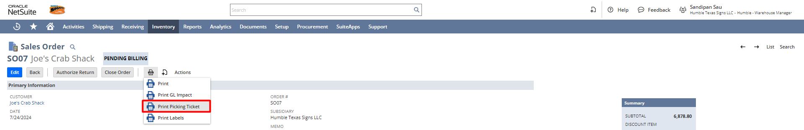
Picking Ticket PDF:
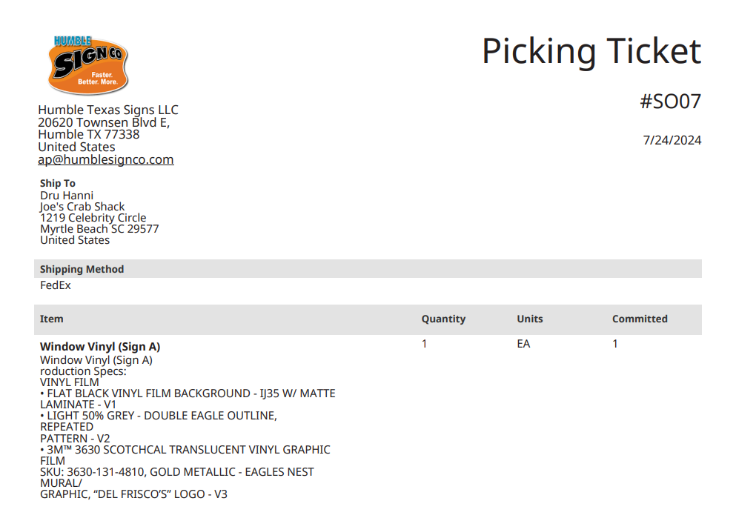

Login To Role: A/R Analyst

Create Deposit
Navigate to: Customers -> Sales -> Enter Sales Orders -> List.

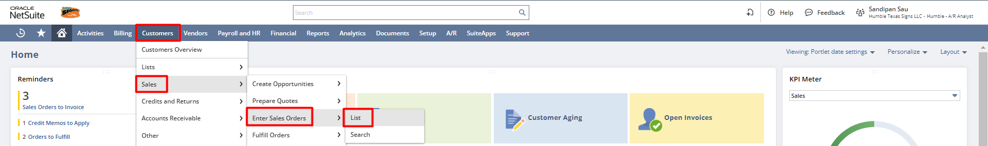

A sales order list will be open as shown below. Click on the view mode of the Sales Order for which you want to create the deposit.
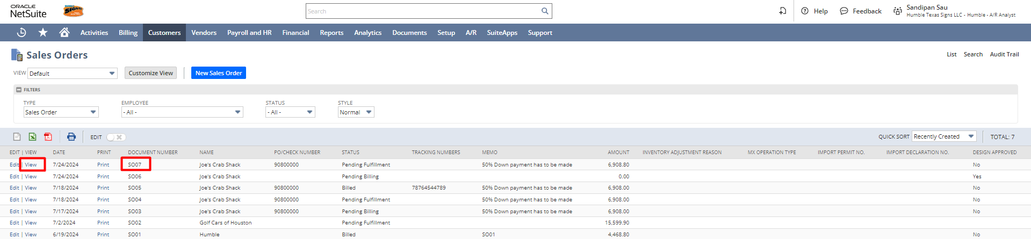

Once the sales order form is open in the view mode. Click on the Create Deposit button.

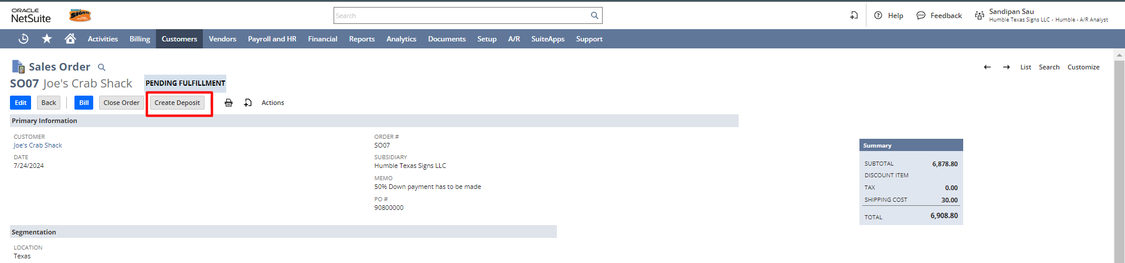
After opening the customer Deposit form change the payment amount to the actual amount as initial deposit. Then click on the save button.

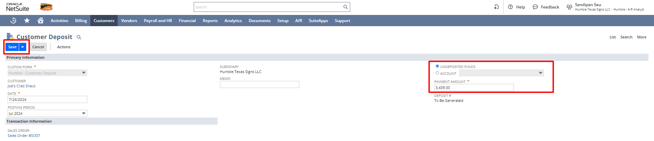

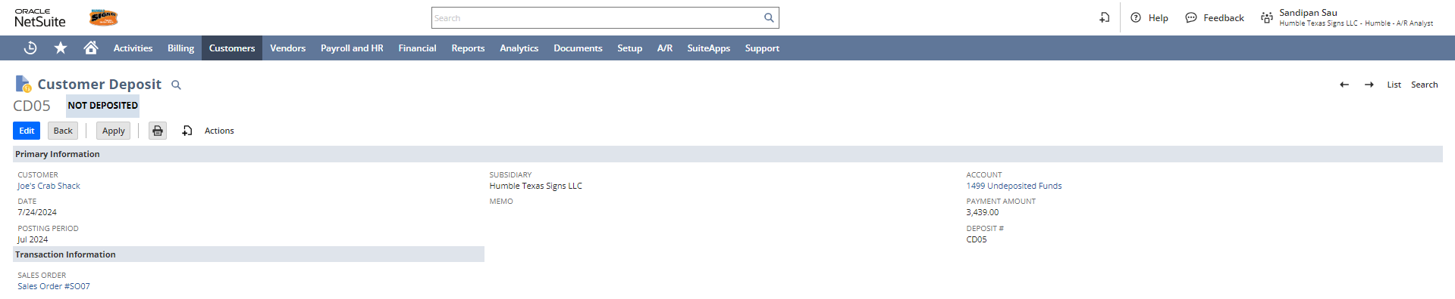
Make Deposit
Navigate to: Financial -> Banking -> Make Deposits
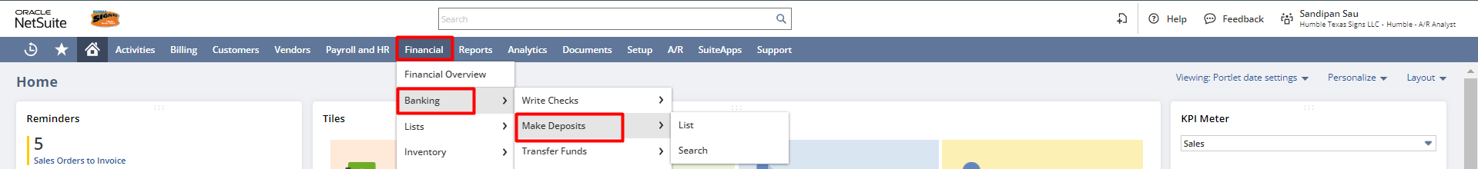
In the Make Deposits form under the Deposits subtab, The Payments subtab lists all payments posted to the Undeposited Funds account. Check the box next to each item to include in this deposit, then in the Amount field automatically fetch the total amount of payments, entered on the Deposits subtab, also if needed you can change the bank account for the deposit, and click on Save
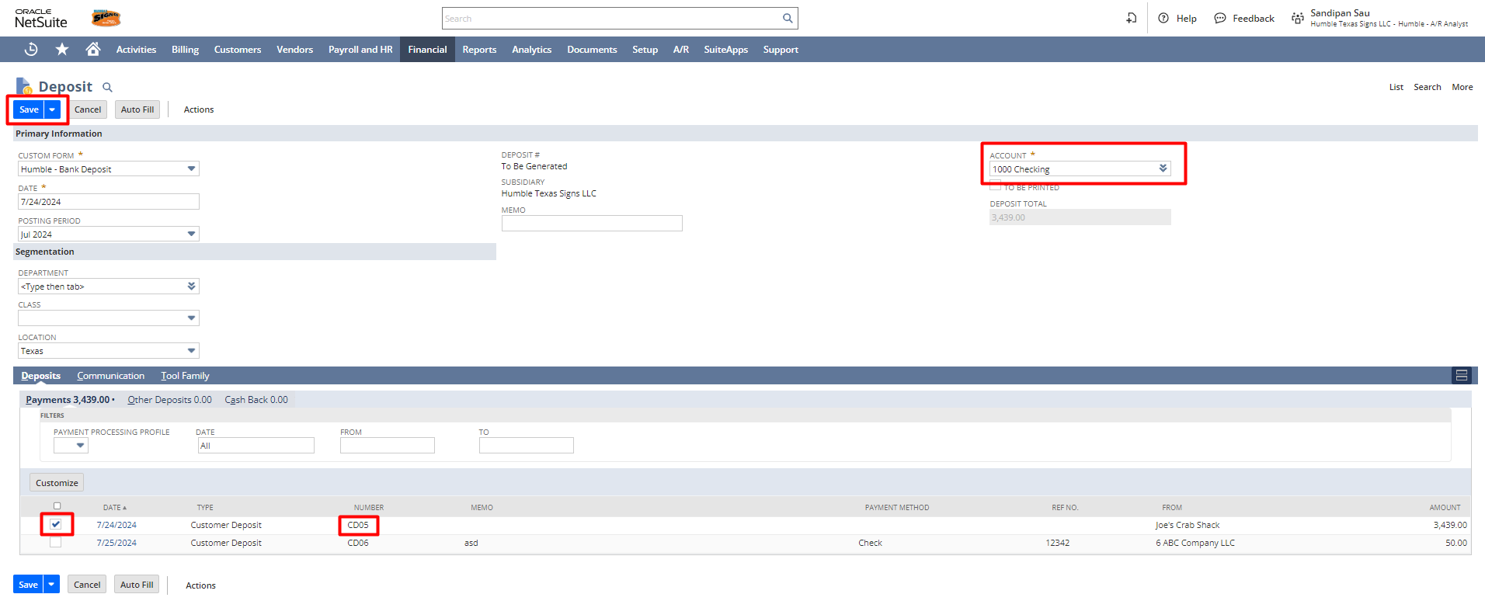Login To Role: Warehouse Manager

Create Fulfillment
Navigate to Shipping -> Other -> Enter Sales Orders -> List
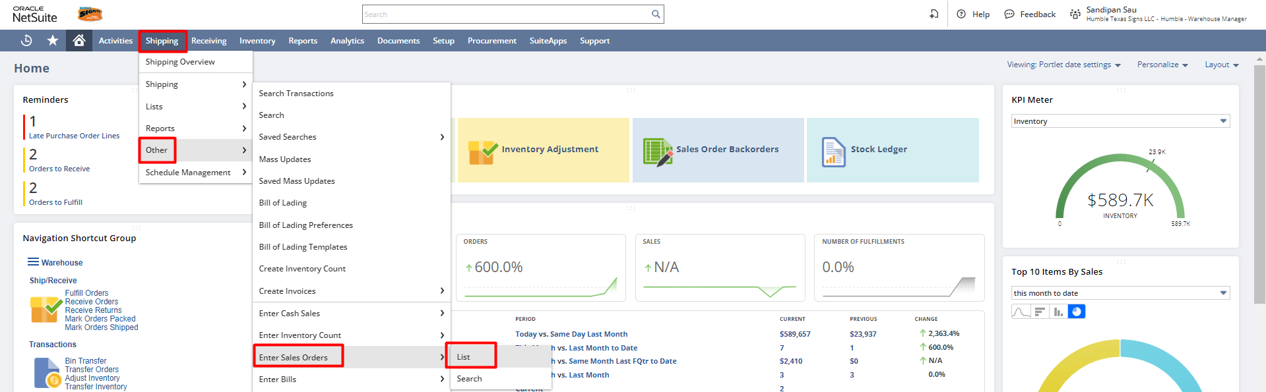
Choose the Sales Order from the list for which you want to make the fulfillment

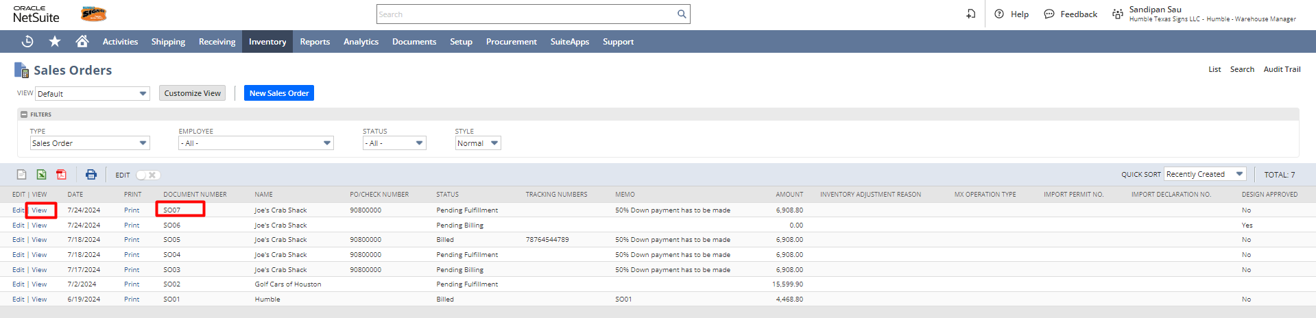
Click on the Fulfill button to make the fulfillment.
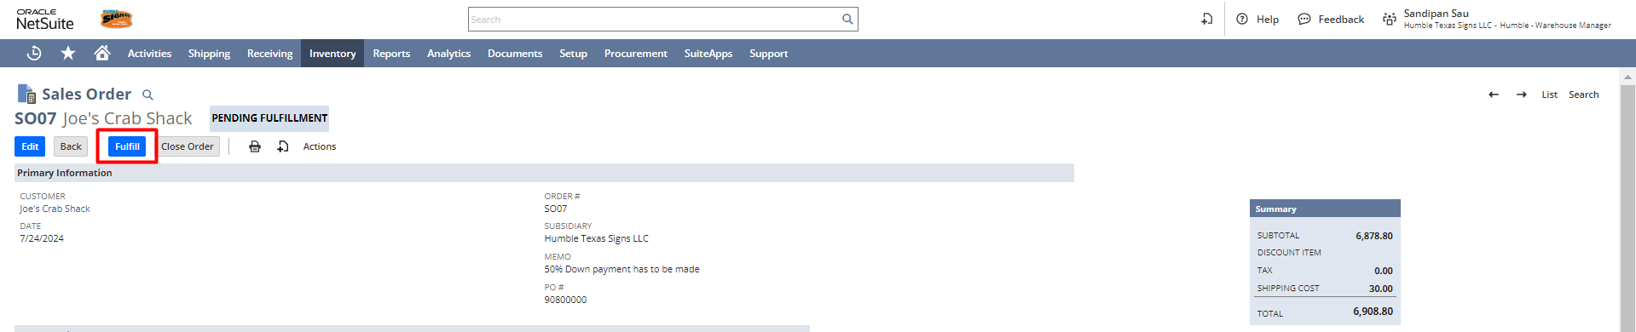
Or,
Click on the Orders to Fulfill hyperlink from the Warehouse Manager Dashboard Reminders section.

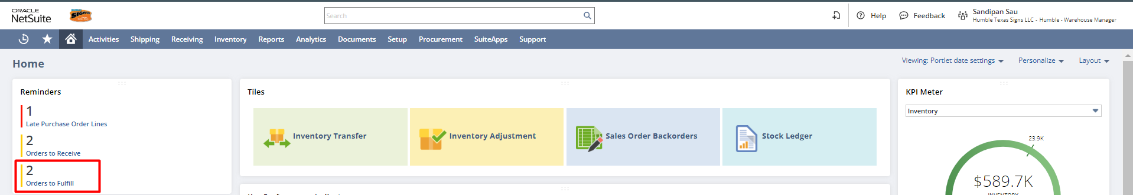
Or,
You can click on the Fulfill link and view the fulfillment if you wish to make any changes in the fulfillment record and then save the Fulfillment record.

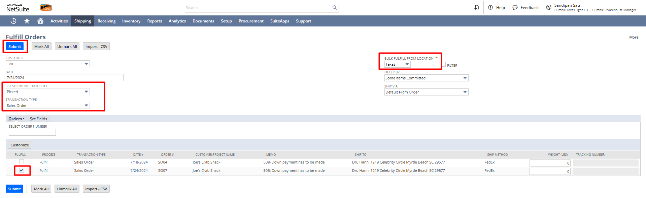

To view the list of fulfillments, navigate to Shipping -> Shipping -> Fulfill Orders -> List.
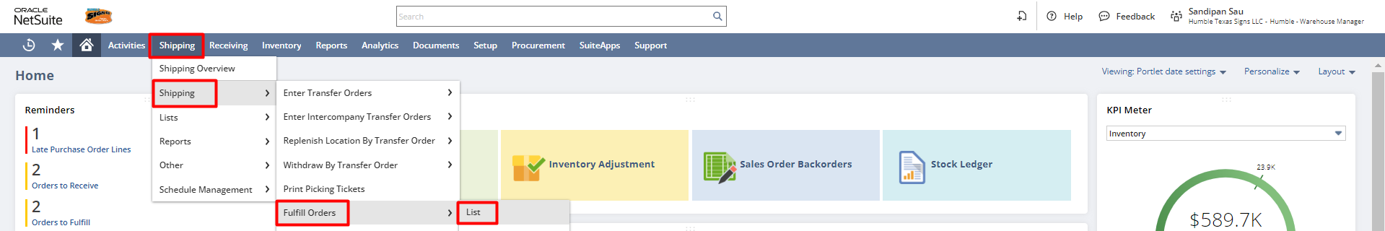

A list of Fulfillments will open. Select the previously created fulfillment and click on the “View” hyperlink to open the fulfillment.
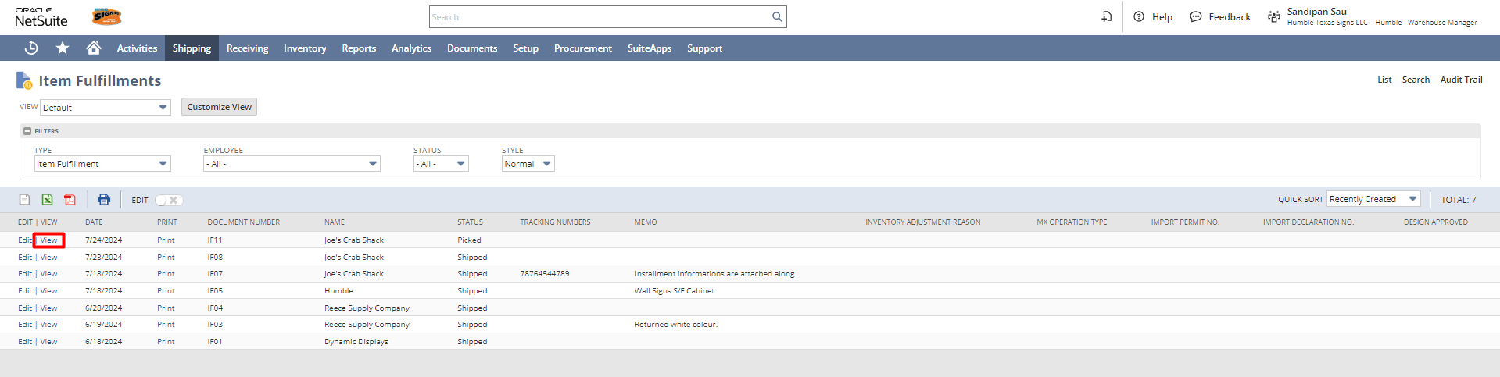

From the fulfillment page click on the “Mark Packed” button to convert the fulfillment status as Packed.

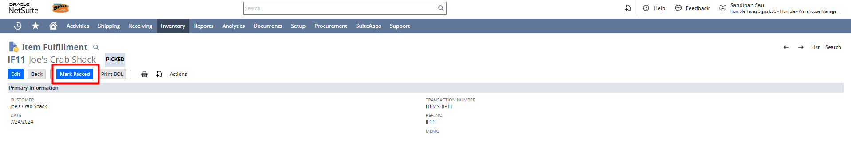
After clicking the “Mark Packed” button the fulfillment status changed to Packed and click on the “Mark Shipped” button.
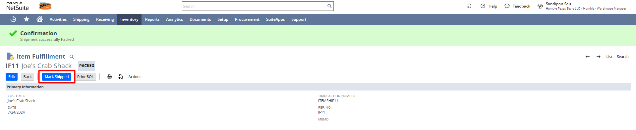

After setting the record as Shipped click on the print button to see the Packing list PDF.
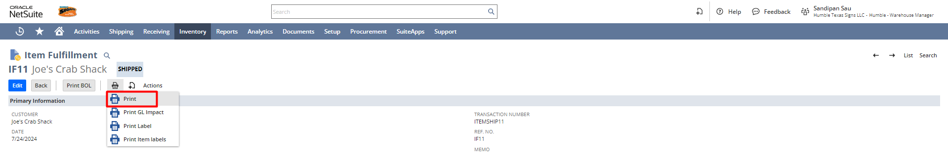

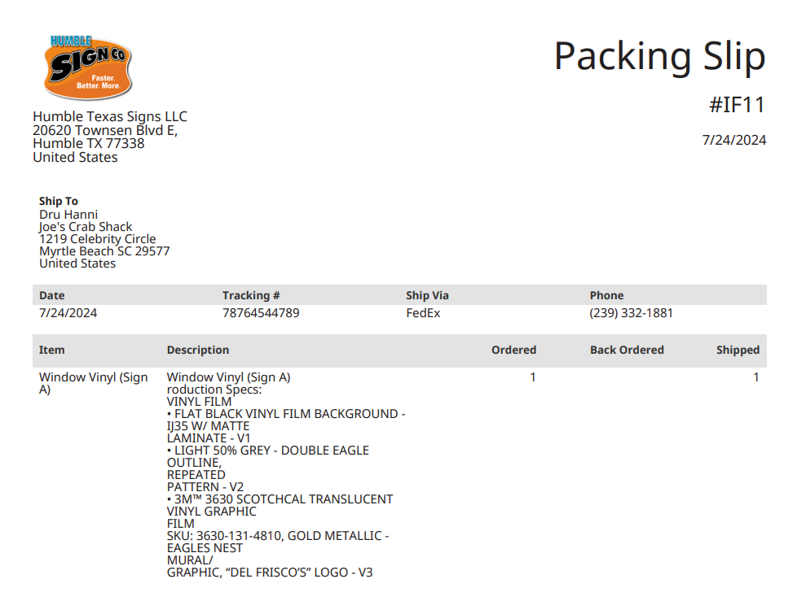
Login To Role: A/R Analyst

Create Invoice
Navigate to Billing -> Sales -> Invoice Sales Orders.
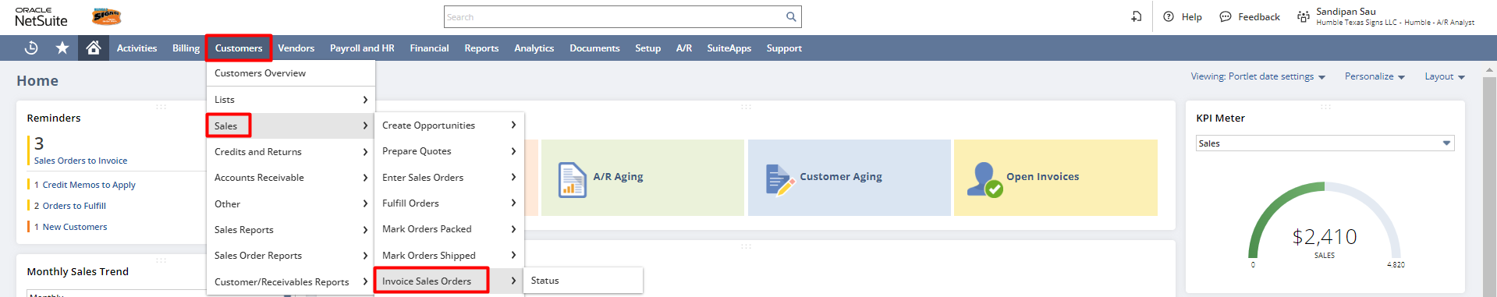

A list of Sales Orders will open, you can check the checkboxes and set the appropriate A/R account and click on submit to create the invoice.
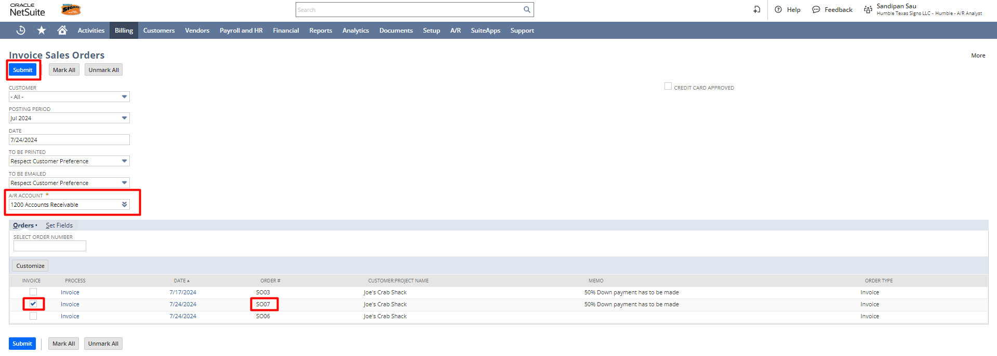

When the status is fully completed in the Process Status Page, go to Billing -> Sales -> Create Invoices -> List to find the created Invoice.

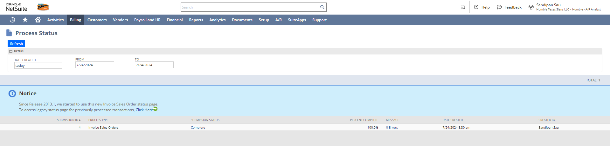

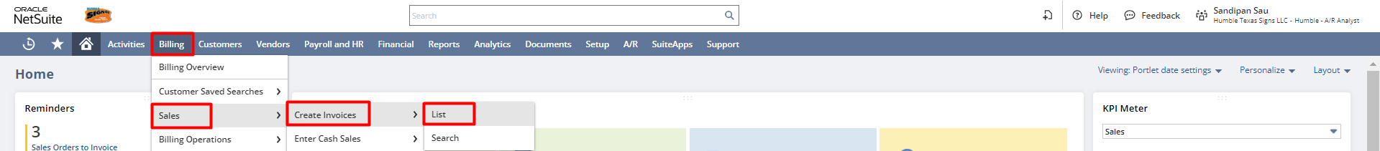

Click on the View to view the Invoice.
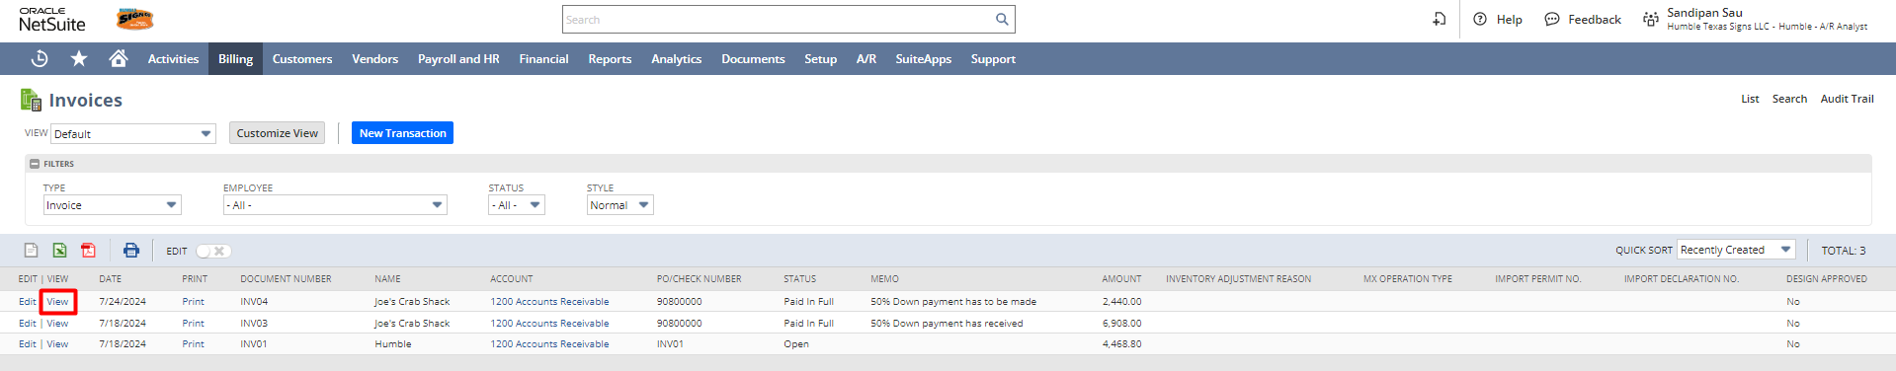

All necessary details populated from the sales order record.
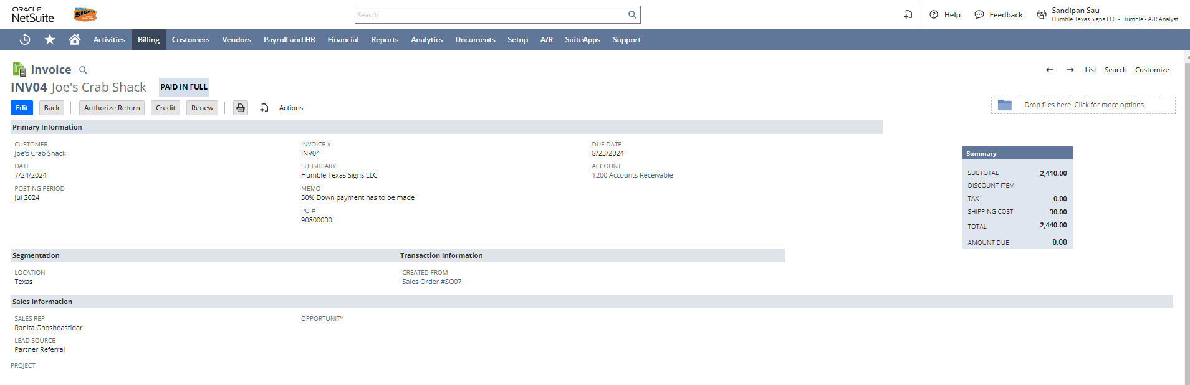
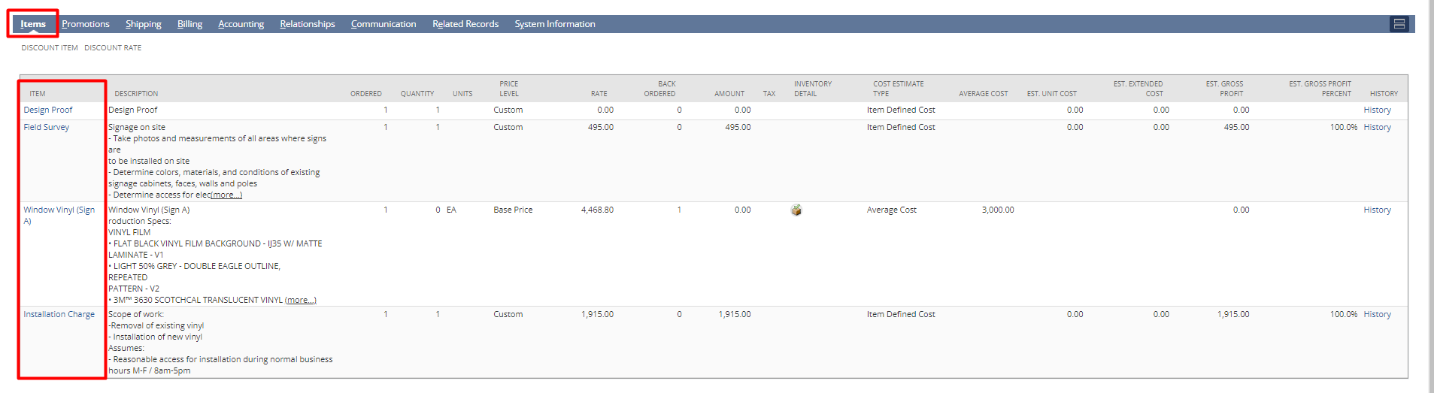

Under the Shipping subtab, the shipping information will be auto-populated from the Sales order.
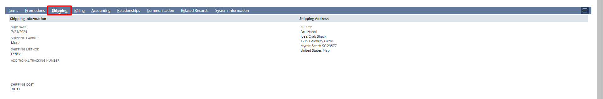

Under Billing tab, Billing information will be auto-populated from the Sales order.

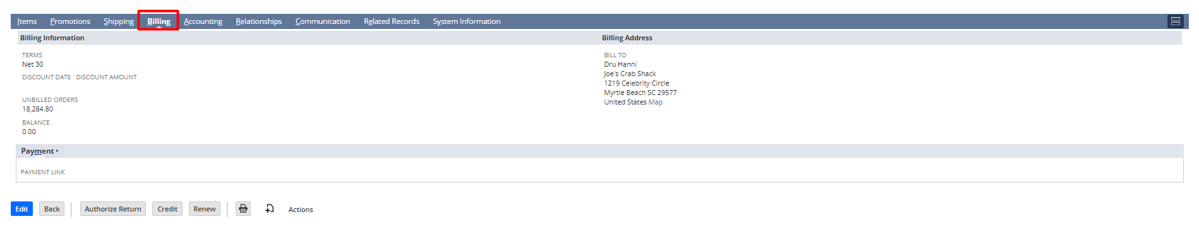
Under the communication tab, you can add a mail address to send automatic mail with the attached PDF.
[NOTE: Check the To BE E-MAILED checkbox after putting the email address]

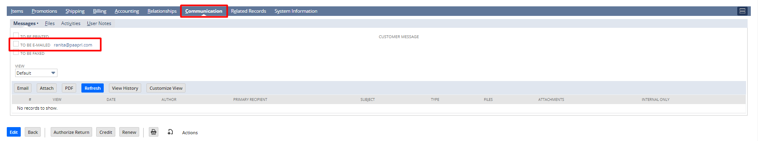

Click on the Print button for the Invoice PDF.
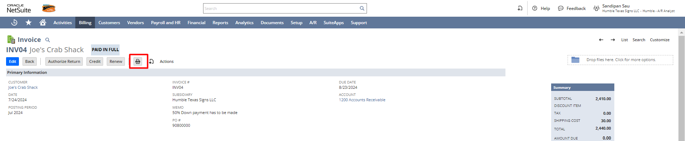
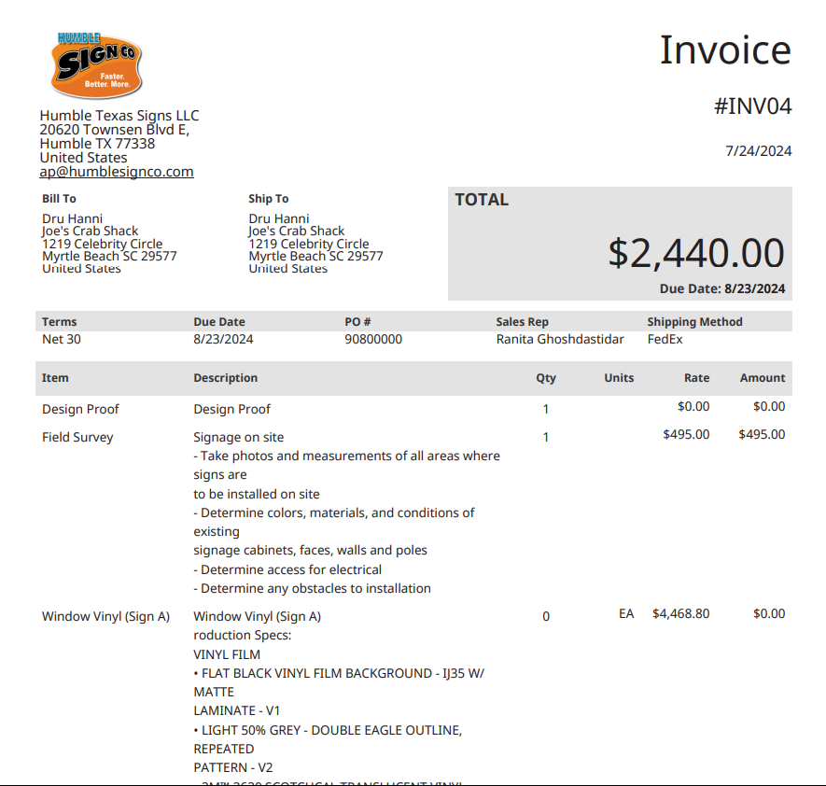

OR

Accept Payment
To create the payment record against an Invoice, navigate to: Customers -> Sales -> Create Invoices -> List.
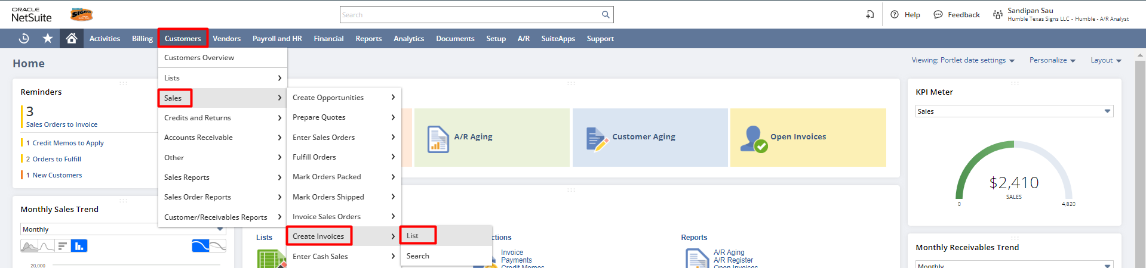
A list will open, click on the View hyperlink to open the particular Invoice for which you want to create the payment record.
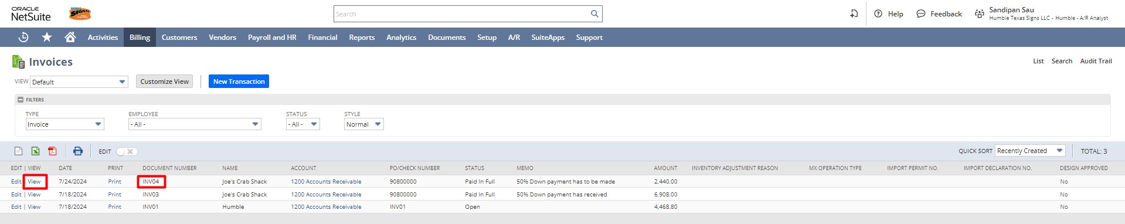
The Invoice record will open and click on the Accept Payment button.

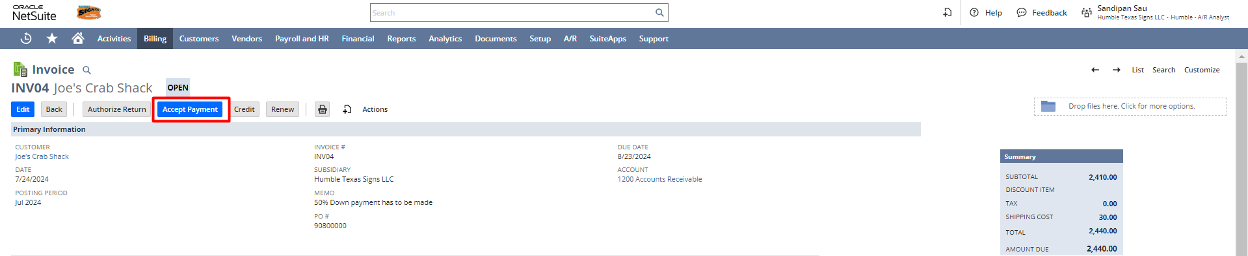

The payment page will open. You need to select the account and modify the payment amount, and click on Save.

Signature: _ Date: _ _
Disclaimer:
Upon signing off on the process flow document, you are confirming that the process has been set up per the SOW within NetSuite per your business's needs. Any changes or modifications requested after sign-off will need to be a "change request" at an additional fee.
*** PLEASE ensure that you have logged into NetSuite and tested the process prior to signing off on the setup. Paapri requires sign-off on this document prior to moving forward with any additional design meetings.

